**Power Apps Portals Integration with AD**

**Exercise 1: Configure the Azure Active Directory**

1. Go to [Power Apps](https://make.powerapps.com/).
2. On the left pane, select **Apps**.

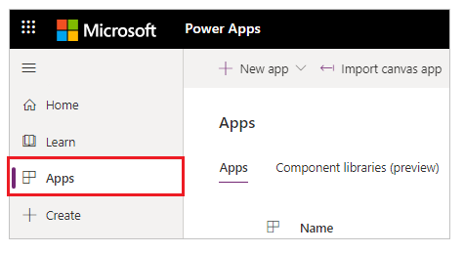

1. Select your portal from the list of available apps.
2. Select **Settings** from the top menu. You can also select **More Commands** (**...**), and then select **Settings**.

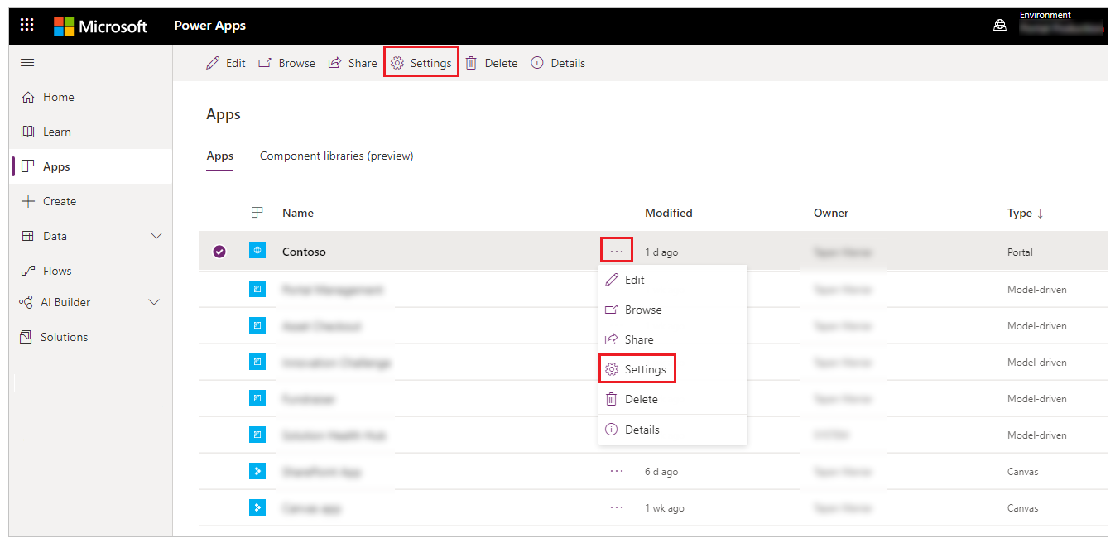

1. From the settings on the right side of your workspace, select **Authentication Settings**.

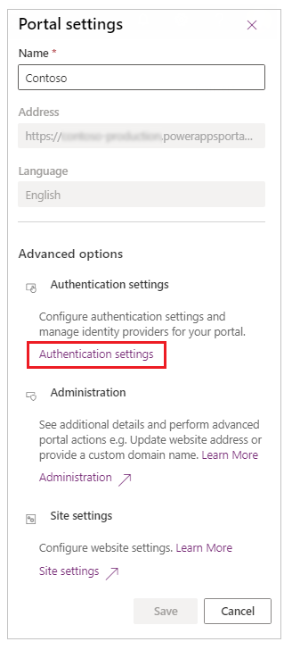

You'll see a list of identity providers that you can configure.

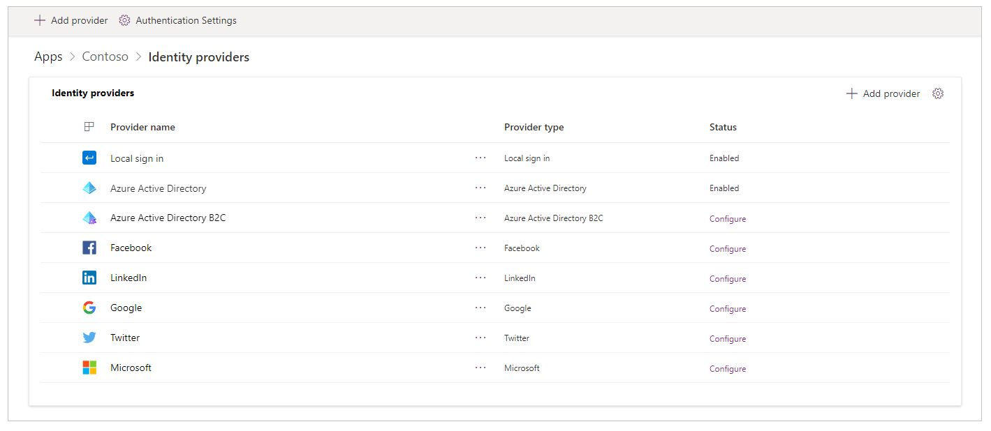

**To view identity providers from the portal details page**

1. Select your portal from the list of available apps.
2. Select **Details** from top menu. You can also select **More Commands** (**...**), and then select **Details**.

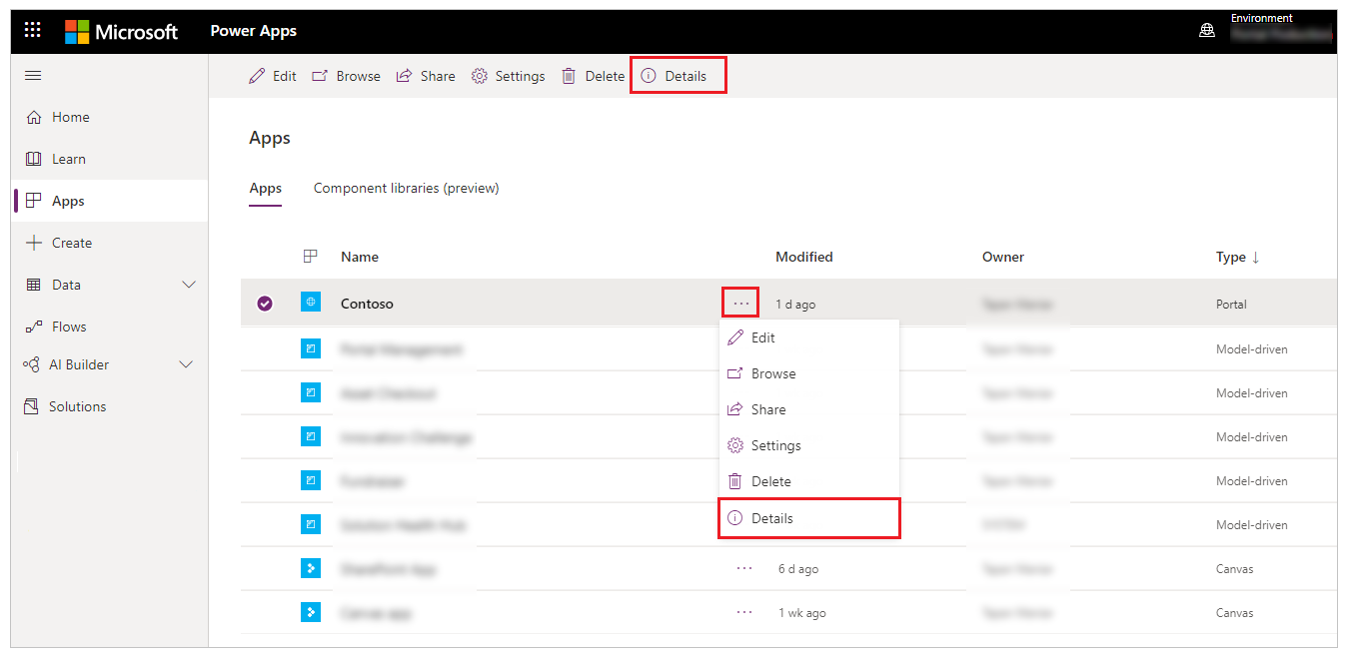

The details page displays the **Identity provider’s** section.

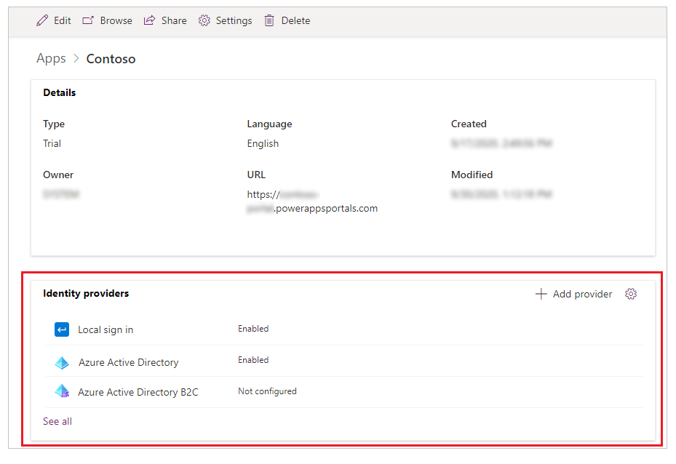

**Configure general authentication settings**

You can configure the following general authentication settings by selecting **Authentication Settings** on the **Identity provider’s** page.

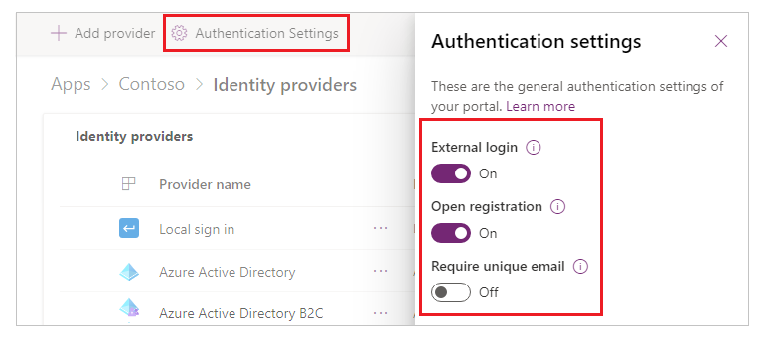

You can also go to general authentication settings from the portal details page by selecting **Settings** in the upper-right corner of the **Identity provider’s** section.

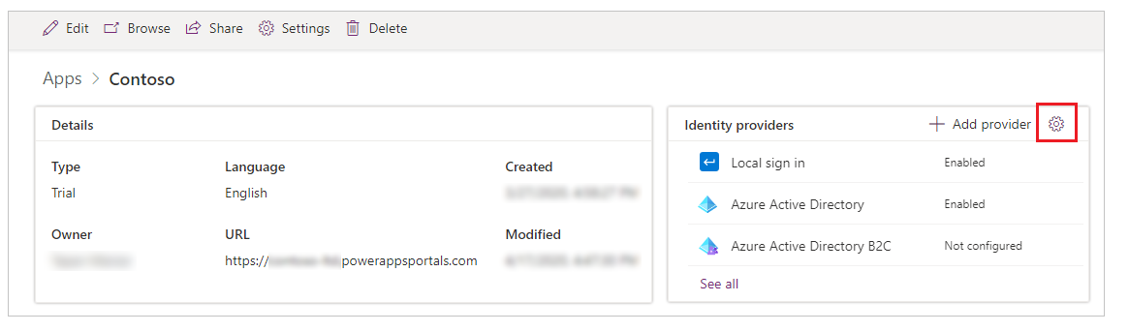

**Configure a default identity provider**

You can set any identity provider as the default. When an identity provider is set as the default, users signing into the portal aren't redirected to the portal sign-in page. Instead, the sign-in experience always defaults to signing in by using the selected provider.

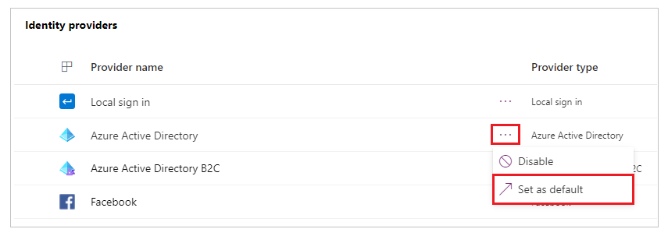

**After set default**

**Test the authentication**

Sign in by using a local identity or external identity

Go to **Apps** 🡪 Open Portal i.e., **Contoso**

Click Sign In

Login using Active directory user Ex: [user@domain.onmicrosoft.com](mailto:user@domain.onmicrosoft.com)

Fill all user information and save it

